High accuracy diagnosis for MRI imaging of Alzheimer’s disease using XGBoost.

Esraa M. Arabiª, Ashraf S. Mohraª, Khaled S. Ahmedª*, for the Alzheimer's Disease Neuroimaging Initiative^{b}

ªElectrical Engineering Department, Benha Faculty of Engineering, Benha University, Benha, Egypt.
^{b}Data used in preparation of this article were obtained from the Alzheimer's Disease Neuroimaging Initiative (ADNI) database (adni.loni.usc.edu). As such, the investigators within the ADNI contributed to the design and implementation of ADNI and/or provided data but did not participate in analysis or writing of this report. A complete listing of ADNI investigators can be found at: http://adni.loni.usc.edu/wp-content/uploads/how_to_apply/ADNI_Acknowledgement_List.pdf

Esraa M. Arabi
esraa.araby@bhit.bu.edu.eg
+20 1022415970
ORCID: 0000-0003-0130-5693

Ashraf S. Mohra
A.mohra@bhit.bu.edu.eg

Khaled S. Ahmed
Khaled.sayed@bhit.bu.edu.eg
+20 1005769386

Blue color: It is the first corrections and replied comments.
Green color: It is the second corrections.
High accuracy diagnosis for MRI imaging of Alzheimer’s disease using XGBoost.
Abstract
Introduction
Alzheimer’s disease (AD) is the most epidemic type of dementia. The cause and treatment of the disease remain unidentified. However, when the impairment is still at a preliminary stage or mild cognitive impairment (MCI), the symptoms might be more controlled, and the treatment can be more efficient. As a result, computational diagnosis of the disease based on brain medical images is crucial for early diagnosis.
Methods
In this study, an efficient computational method was introduced to classify MRI brain scans for patients with Alzheimer’s disease (AD), mild cognitive impairment (MCI), and normal aging control (NC), comprising three main steps: I) feature extraction, II) feature selection III) classification. Although most of the current approaches utilize binary classification, the proposed model can differentiate between multiple stages of Alzheimer’s disease and achieve superior results in early-stage AD diagnosis. 158 magnetic resonance images (MRI) were taken from the Alzheimer’s Disease Neuroimaging Initiative database (ADNI), which were preprocessed and normalized to be suitable for extracting the volume, cortical thickness, sulci depth, and gyrification index measures for various brain regions of interest (ROIs), as they play a considerable role in the detection of AD. One of the embedded feature selection methods was used to select the most informative features for AD diagnosis. Three models were used to classify AD based on the selected features: extreme gradient boosting (XGBoost), support vector machine (SVM), and K-nearest neighborhood (KNN).
Results and Conclusion
XGBoost showed the highest accuracy of 92.31%, precision of 0.92, recall of 0.92, F1-score of 0.92, and AUC of 0.9543.
Keywords: Cortical Thickness, Gyrification Index, Sulcal Depth, Alzheimer’s Disease, SVM, KNN, XGBoost.

1. INTRODUCTION
Alzheimer's disease (AD) is a cumulative neurodegenerative disease for which there is currently no cure. However, the detection of the disease at an earlier stage can assist in slowing down the progression of AD. Neuropathological changes due to AD appear prior to the onset of clinical symptoms. Hence, there is a need to detect brain alterations at an early stage and identify biomarkers that are most associated with mild cognitive impairment (MCI) and AD.
Structural magnetic resonance images (MRI) biomarkers including brain regions morphometry, texture, volume, and cortical measurements, have been used to classify the main stages of Alzheimer’s disease: normal control (NC), MCI, and AD. Many automatic approaches have been used for extracting biomarkers from MRI [1-5] such as: region of interest analysis (ROI) methods. The goal of ROI analysis is to map labelled ROIs from a brain atlas (volume and surface-based atlas maps) to a target brain via automated high-dimensional registration to obtain labelled ROIs from the target. Following this, regional tissue measurements such as ROI volume, cortical thickness, sulcal depth, and gyrification index were estimated. To accomplish this automatic feature extraction and analysis, there are various software packages such as Statistical Parametric Mapping (SPM), Computational Anatomy Toolbox (CAT12) [6], and FreeSurfer [7].
The chief concerns addressed in several studies for diagnosing AD at its early stages are building more efficient biomarkers from MRI scans for AD detection. The use of various machine learning classifiers to select features related to Alzheimer's and to develop an accurate detection system is a current area of research. MRI scans have been studied to obtain several Alzheimer's biomarkers and to study the most atrophic regions using volume [8,9], shape [10], texture [11], cortical [12,13], and sulcal measurements [14]. These measurements were performed on various affected brain regions, including the hippocampus [15], amygdala [16,17], whole brain [18], entorhinal cortex [19], brainstem [20] and ventricles [21]. Although volume and cortical thickness are the most dominant biomarkers that have been studied, there have been very few investigations of other surface-based features, such as the gyrification index and sulcal depth in early AD diagnosis. Analysis of the gyrification index and sulcal depth could provide remarkable information about the alterations in the brain shape caused by AD. These alterations are not detected with conventional volumetric analyses but could be captured with cortical gyrification analysis [22]. Sulcal depth and sulcal width were observed to be lower in normal controls and increasing along with the severity level of AD [12,14]. The gyrification index, which is the ratio of the inner surface (GM/WM interface) area to the outer surface area (GM/CSF interface), is an excellent feature for the early diagnosis of patients with mild AD and for separating them from normal controls [22]. Some researchers believed that combining complementary biomarkers which have different information could provide more efficient and accurate evidence for AD, MCI, and NC diagnosis [23].
Recent advances in machine learning techniques, such as support vector machine (SVM), K-nearest neighbor (KNN), decision tree [24], and ensemble models [25] enhance the process of disease diagnosis and increase the accuracy through automated systems instead of focusing entirely on physician experiments. However, selecting the best biomarkers that represent Alzheimer's is a major challenge which can be used to distinguish between stages of the disease. The particle swarm optimization (PSO) algorithm [26], XGBoost [27], RFE-SVM [28], and t-test [29] are some of the feature selection methods that have been employed in recent studies. One study developed a method by combining SVM and particle swarm optimization (PSO) for classifying AD from NC with an accuracy up to 94.12% and 88.89% for classifying MCI from NC, using volume and shape features [30]. Another study demonstrated 96.5% classification accuracy for AD/NC by investigating the temporal lobe and whole-brain gray matter [31]. Furthermore, a multistage classifier-based method used 88 features (50 volumes and 38 regional cortical thicknesses) to predict AD/MCI/NC with an accuracy up to 81.3%. On the other hand, one report obtained 0.52 average precision, 0.56 average recall for classifying AD, MCI and NC using an ensemble random forest. Moreover, a surface-based morphometry report differentiated between AD and NC with 93.3% specificity and 87.1% sensitivity [32].
Our contribution is to have the most beneficial number of features among a large pool of AD biomarkers to differentiate between AD stages and diagnose the early stage with high accuracy using XGBoost. In this study, MRI scans were acquired from the Alzheimer’s Disease Neuroimaging Initiative (ADNI) and processed to extract volumetric features for 81 brain regions. In addition, cortical thickness, sulcal depth, and gyrification index features were obtained for 68 brain regions and all features were combined to get 275 attributes. We used XGBoost to find the best features that represent Alzheimer's disease in order to build a more precise classification system. At last, three different classifiers (XGBoost, SVM, and KNN) were used to compare the classification accuracies.
2. DATA AND METHODS
2.1. Database
Data required for this study were obtained from the Alzheimer's Disease Neuroimaging Initiative (ADNI) database (http://adni.loni.usc.edu). ADNI was propelled as a public-private corporation by six nonprofit organizations in 2003: the National Institute on Aging (NIA), the National Institute of Biomedical Imaging and Bioengineering (NIBIB), the Food and Drug Administration (FDA), and private pharmaceutical companies. ADNI's main objective was to check whether some specific biomarkers, clinical and neuropsychological assessment, positron emission tomography (PET), and serial MRI can be combined to evaluate MCI evolution and early Alzheimer's.
158 T1-weighted MRI scans have been taken from ADNI, 26 female cases and 28 male cases in AD stage, 28 females and 25 males in NC stage and in MCI stage, 27 females and 24 males. The age range of the participants was 50-85 years. The imaging parameters were as follows: magnetic field strength =3T, flip angle= $9^{°}$, repetition time = 2,300 ms, echo time = 3.0 ms, slice thickness =1.2 mm, acquisition matrix = 240 ×256, pixel spacing X=1.0 mm; pixel spacing Y=1.0 mm and number of slices = 176. There are some criteria that were not considered in the dataset such as the Clinical Dementia Rating Scale (CDR), Mini-Mental State Examination (MMSE), chronic diseases and medical history of the patient. Demographic characteristics of the subjects are presented in Table 1.
Table 1. Sample size for each class
Class | Female | Male | Sample size/each class
AD | 26 | 28 | 54
MCI | 27 | 24 | 51
NC | 28 | 25 | 53
Total | 81 | 77 | 158

2.2. Image Analysis
Data were collected from ADNI and preprocessed using CAT12. The preprocessing workflow included a spatial adaptive nonlocal means (SANLM) denoising filter [33] to reduce noise while preserving edges, bias field inhomogeneity correction, and affine registration to get further high-quality segmentation outcome, skull stripping with adaptive probability region growing (APRG) approach, and segmentation to three tissues (GM, WM and CSF) using Adaptive Maximum A Posterior (AMAP) technique [34]. Thereafter, spatial normalization of the three tissues was performed using the DARTEL [35] template. Then, the Hammers atlas [36], one of the volume atlases was used to calculate GM and WM volumes for specific brain regions. Surface-based processing was performed following the completion of the previous processing. Using the projection-based thickness (PBT) method [37], cortical thickness was estimated and the central cortical surface was reconstructed. The central surface is the surface between the inner (WM/GM boundary) and outer (GM/CSF boundary) cortical surfaces, which represents the cortex well, and enables reliable estimation of cortical parameters (GI, SD). Ultimately, 71 raw volumetric measurements and 68 cortical thickness (CT), 68 gyrification index (GI), and 68 sulcal depth (SD) measurements were extracted. Volume measurements involving the hippocampus, amygdala, temporal pole, fusiform, insula, putamen, thalamus, lateral temporal ventricle, and cuneus were normalized by the intracranial volume. Relative volumes provided more precise volumes by reducing the influence of factors such as head size and brain size. Surface-based features (CT, GI, and SD) include entorhinal, temporal pole, insula, fusiform, parahippocampus, insula, etc. By combining volume with surface-based features, we will collect most of the important parameters to indicate the existence of the disease, as they are complementary biomarkers with valid information (fig. 1).
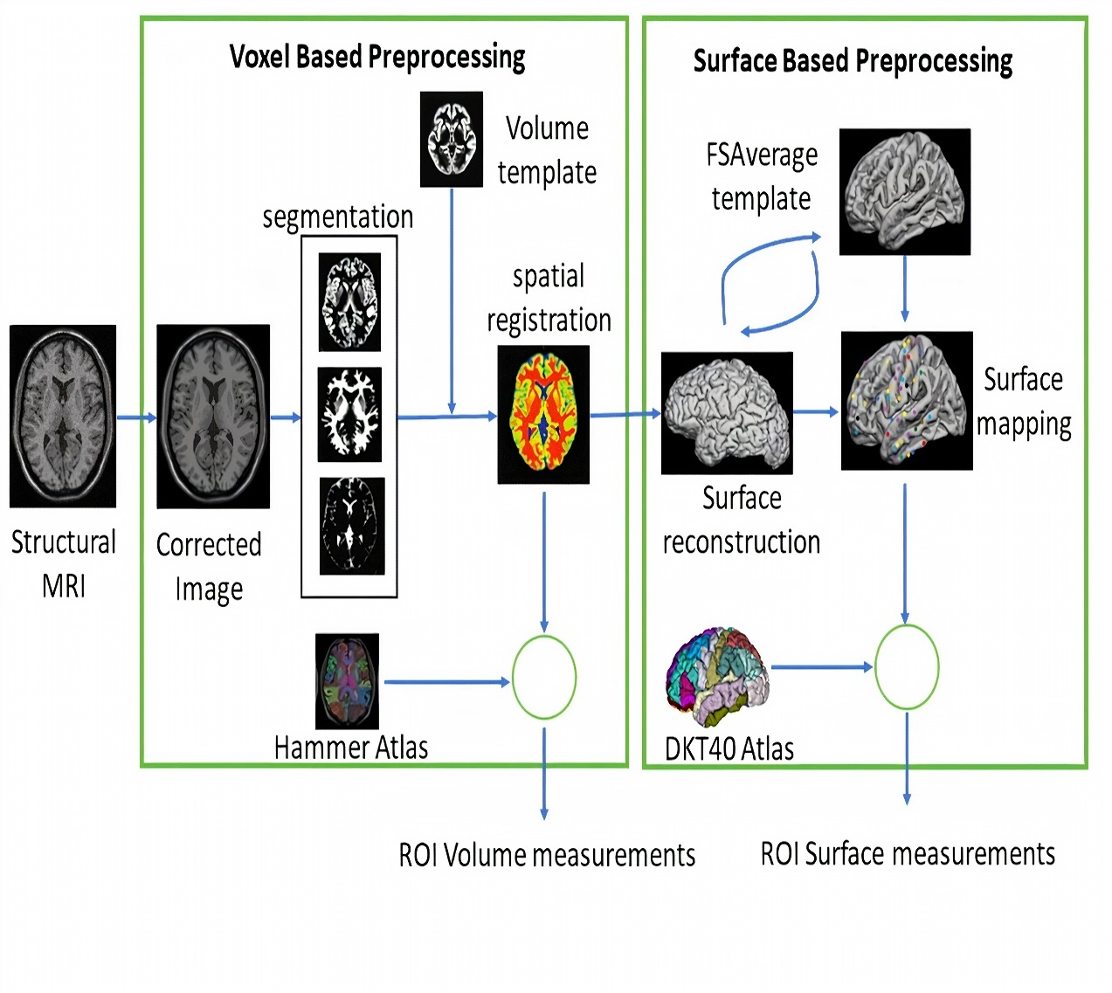
Fig. (1). The workflow of medical image structural MRI preprocessing (Region-based morphometry (RBM))

2.3. Features Selection
Feature selection process uses a specific algorithm to determine the most dominant features that contribute more to the prediction variable to improve model accuracy and reduce computational cost. There are three feature selection methods: filter, wrapper, and embedded. In embedded methods, feature selection can be used as a part of the training process, as the model picks features which maximize accuracy [38]. Embedded methods have an advantage over wrapper methods in that they eliminate the computation time required to reclassify different subsets. Moreover, they outrank filter methods by considering the dependencies between features [39]. Therefore, there is no need to take a step of inspecting the correlation between features with each other. Thus, we used one of the embedded feature selection methods, which is XGBoost to get the top-ranked features.
We have a high-dimensional feature vector, 68×3 surface-based features (cortical thickness, sulcal depth, gyrification index), and 71 volumetric features, and not all of them have important information for diagnosing AD.
In XGBoost, we chose the gain value associated with each feature to rank them. The gain parameter for each feature corresponds to the average loss reduction gained when using this feature to split trees. After feature ranking, we built a model by progressively increasing the feature size, starting with the most important features and recording the accuracy. The accuracy stabilized from Features 16 to 21. From Feature 21, it decreased by 15% approximately. Adding more features will not improve the performance and make the model more complex. Thus, the number of features is limited to 16.

2.4. Classification
In the classification step, two conventional techniques have been used: SVM, KNN, and one of the recent technology models such as XGBoost. XGBoost is an enhanced version of the gradient boosting ensemble learning method with highly precise and promising results, which is implemented by Guestrin [40]. XGBoost comprises a series of decision trees (weak learners) that are created in a sequential manner, and consequently combine their decisions to predict the target. As shown in Fig. (2), one tree (weak classifier) is fitted to a split of features to begin the training. It then fits another tree based on the training error (residual) from the previous tree and this process is repeated. The final predicted output combines all results of the tree.

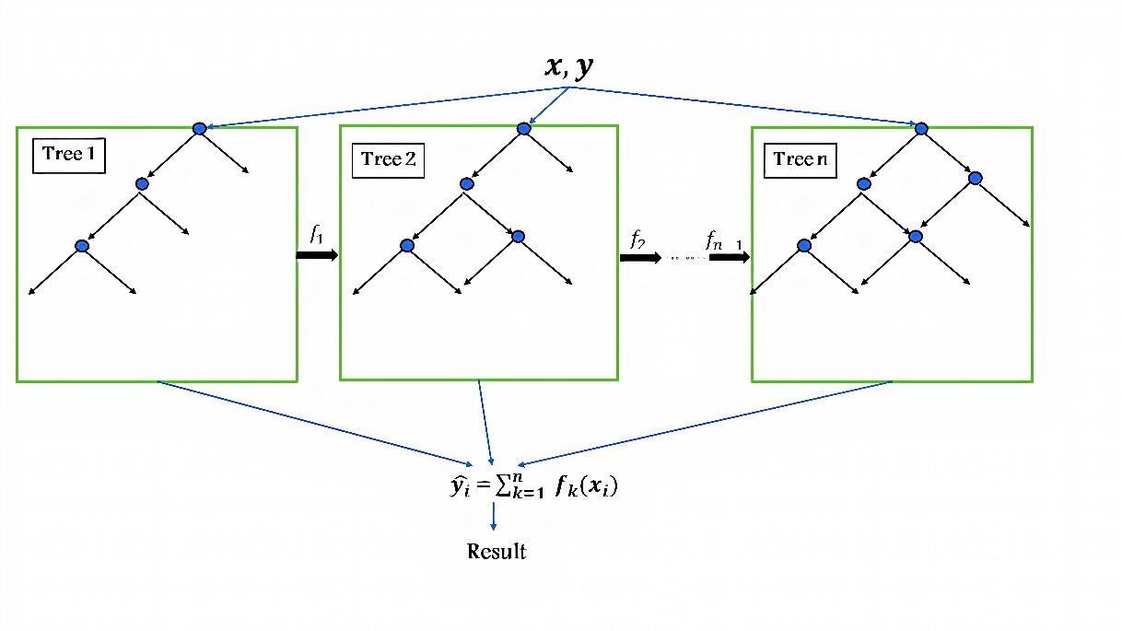
Fig. (2). The basic structure of XGBoost algorithm.

The prediction function is defined as:
$\hat{y_{i}}$ = $\sum_{k=1}^{n}{ f_{k}(x_{i})}$ (1)
where $y_{i}$ is the predicted class of the i-th observation, $x_{i}$ is the corresponding feature vector, and k is the total number of decision trees. $f_{k}\left(x_{i}\right)$ is defined as:
$f_{k}\left(x_{i}\right)=w_{qk}\left(x_{i}\right)$ (2)
$w_{qk}\left(x_{i}\right)$ is the structure function of the k-th decision tree that maps $x_{i}$ to the corresponding leaf node, $w$ is the vector of leaf weights.
XGBoost uses gradient descent to minimize the errors of weak learners. The objective function is expressed as follows:
O = $\sum_{i}{l\left(\hat{y_{i}},y_{i}\right)}$ + $\sum_{k}{Ω}\left(f_{k}\right)$ (3)
where $\sum_{i}{l\left(\hat{y_{i}},y_{i}\right)}$ is the loss function that measures the deviation between the prediction $\hat{y_{i}}$ and the true value $y_{i}$, $\sum_{k}{Ω}\left(f_{k}\right)$ is the regularization term. (Tree model complexity penalty term) $Ω\left(f_{k}\right)$ is defined as:
$Ω\left(f_{k}\right)$ = γT + $\frac{1}{2}$ λ$\sum_{j=1}^{T}{{w^{2}}_{j}}$ (4)
where T is the number of leaf nodes, γ is the weight of the leaf nodes, and λ and $w$ are regular coefficients. The model is being trained in an additive manner. Let ${\hat{y}}_{i}^{(t)}$be the predicted value of the i-th observation at the t-th iteration, and the prediction function is:
${\hat{y}}_{i}^{(t)}$= ${\hat{y}}^{\left(t-1\right)}+f_{t}(x)$ (5)
And the objective function is altered to:
$O^{(t)}=\sum_{i=1}^{n}{l\left(y_{i},{\hat{y}}_{i}^{\left(t-1\right)}+f_{t}\left(x_{i}\right)\right)+} Ω\left(f_{t}\right)$ (6)
The regularization function is responsible for stopping the training of a model when the function determines that the model is sufficiently effective based on the learning score, thereby avoiding the risk of overfitting.
XGBoost uses the second Taylor approximation to optimize the objective function quickly.
$O^{(t)}=\sum_{i=1}^{n}{\left(l\left(y_{i},{\hat{y}}_{i}^{\left(t-1\right)}\right)+{g_{i}f}_{t}\left(x_{i}\right)+\frac{1}{2}h_{i}f_{t}^{2}\left(x_{i}\right)\right)+}Ω\left(f_{t}\right)$ (7)
XGBoost is faster than gradient boosting because it uses the power of parallel processing, which makes it possible to train on large data in a better manner. It also deals with small and sparse data efficiently and uses regularization to avoid overfitting. XGBoost includes a large variety of tuning parameters for cross-validation, regularization, user-defined objective functions, missing values, and tree parameters. It uses the features of each MRI image to train and evaluate the importance score, which implies how significant the related feature was in the building of the boosted decision trees within the model. The values used for each parameter are explained in Table 2.

Table 2. Key parameters used for XGBoost classification.
Parameter | Default | Description
learning rate (eta) | 0.3 | Shrink the weights on each step
N_estimators | 100 | Number of trees to fit in our ensemble.
objective | multi: softprob | Objective same as softmax, for multiclassification
booster | gbtree | Select the model for each iteration
nthread | max | The core number in the system, used for parallel processing
Minchildweight | 1 | Minimum sum of weights
max_depth | 3 | Maximum depth of a tree.
gamma(γ) | 0 | The minimum loss reduction needed for splitting
Subsample | 1 | Control the sample’s proportion
colsample_bytree | 1 | Column’s fraction of random samples
reg_lambda(λ) | 1 | L2 regularization term on weights

SVM is a supervised machine learning model which is used for classification or regression and has been broadly used in various successful applications. SVM chooses the best hyper-plane or a group of hyper-planes that maximizes the distance of the margin between classes to classify data. For non-linearly separable data, SVM utilizes a kernel function that maps the input data (training samples) to a higher dimensional space, such as Gaussian kernel [41]:
$K\left(x,y\right)=exp\left(-γ{\left|x-y\right|}^{2}\right)$ (8)
where $γ$ is gamma, which controls the influence of each training point has on the position of the decision boundary, ${\left|x-y\right|}^{2}$ can be defined as squared the Euclidean distance between the two feature vectors.
We used polynomial kernel, polynomial order was 3 and box constraint was 5.23.
KNN is a supervised nonparametric machine learning method. It stores and arranges all labelled data in memory during the training process; therefore, it is memory dependent and does not require model fitting. The test point is then classified based on a similarity measure between this point and its neighbors. Given x0 as a new point, KNN search selects the k-nearest points in terms of distance to x0. The number of data points in each class is counted among these k neighbors, and the data points are classified based on votes from the neighbors [42]. Cityblock was used to measure the distance between points, and the number of neighbors was 12.
Instead of using all features for classification, feature selection approaches are commonly used to improve the accuracy and performance, especially for high-dimensional datasets. XGBoost was used for feature selection, and XGBoost together with SVM and KNN were again used to classify the brain MRI scans into three classes: AD, MCI, and NC. The proposed classification approach is shown in Fig. (3).

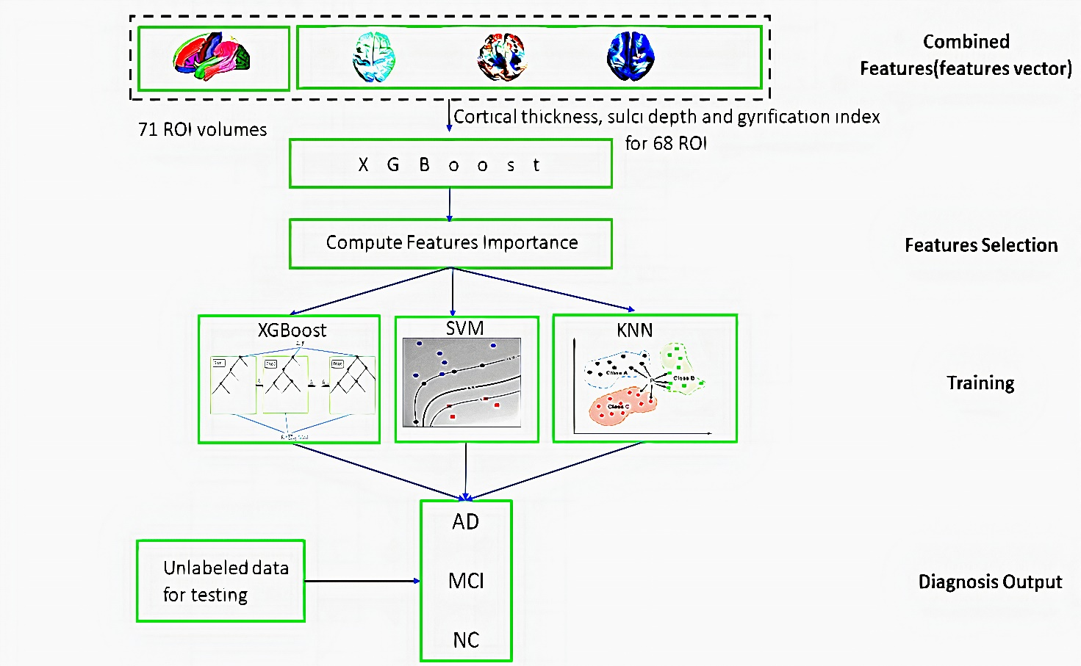

Fig. (3). Schematic diagram of the proposed approach

3. RESULTS
There were 158 cases in this study, 119 (41 NC, 40 MCI, 38 AD) participants for training models, and 39(12 NC, 11 MCI, 16 AD) participants for testing the performance of the classifiers. The features are in four main groups: volume features, cortical thickness, sulcal depth, and gyrification index. Volume was measured in 71 regions of interest (ROI) of the brain. Each of the other three features was measured for 68 ROI, as explained in Appendix 1.
The XGBoost algorithm was used to obtain feature importance. Feature importance is a score that illustrates the value of each attribute in the building of boosted decision trees within the model. The higher the relative importance of an attribute, the more it is used to make key decisions in the decision trees. Feature importance is measured explicitly for each feature in the dataset, by calculating the average decrease in impurity or the error function (such as the Gini impurity) for each feature across all decision trees within the model.
Using the XGBoost algorithm, we ranked all features. Then, starting with the most informative feature, we implemented a method to gradually increase the feature size (number of features) until the features no longer increase the performance (16 and 17 features), the accuracy was fixed at 92.31%, as shown in Fig. (4).
We got 16 top ranked features: from the volume features group: rAmy, lAmy, lSupFroGy, rPosTeLo, and lCbe; from the gyrification index features group: lparahippocampal, lparacentral, rinferiortemporal, rparsopercularis, and rlateralorbitofrontal; from the sulcal depth features group: lsuperiortemporal, lparacentral, and rtemporalpole; and cortical thickness: lentorhinal, lfusiform, and rinsula, as illustrated in Table 3 and Fig. (5).
Subsequently, these features were trained using three classifiers: SVM, KNN, and XGBoost. We considered four commonly used metrics which are ACC (accuracy), SEN (sensitivity), SPE (specificity), and AUC (area under the curve) to evaluate the classification performance. To achieve more stable results and maintain the same distance for all classifiers, we used 10-fold cross-validation to compare all methods: sensitivity=recall= $\frac{TP}{\left(TP+FN\right)}$, precision = $\frac{TP}{TP+FP}$, accuracy = $\frac{TP+TN}{TP+TN+FP+FN}$ , F1-Score =$\frac{2TP}{2TP+FP+FN}$
where TP, TN, FP, and FN are true positive, true negative, false positive and false negative, respectively. Area Under the Curve (AUC) is the two-dimensional area under the receiver operating characteristic (ROC) curve, which is a graph between the precision (y-axis) and recall (x-axis) at various thresholds (0-1).
From Table 4, XGBoost gave the highest accuracy which was 92.31% among the other classifiers (SVM and KNN) with 89.18%. In addition, XGBoost has the best values for all metrics (precision, recall, F1-score, and AUC) over the SVM and KNN. It had precision of 0.92, recall of 0.92, F1-score of 0.92, and AUC of 0.9543, as shown in Table 5 and Fig. (6).
The F1-score and AUC for the MCI stage had the highest values across all three classifiers, which means that with these selected features, we can differentiate the MCI stage from the others (NC and AD) in an excellent manner. Moreover, the AD stage had a quite high F1-score and AUC.
NC was the lowest stage in F1-score among the other stages in all classifiers and had a quite high precision value and which means that all classifiers in their errors tended to classify NC as an AD or MCI patient. This status in disease diagnosis is preferable more than classifying a patient as normal.
We used the original number of features for each group, and from Table 6, we can determine that volume features are the best group of features for detecting AD, followed by GI and CT groups. From the results, the SD feature group alone was not very effective in the diagnosis, although it improved the overall accuracy when it was combined with other feature groups.
In Fig. (7), we performed the training and testing process for the three models (SVM, KNN and XGBoost) multiple times with different numbers of features (14-23 features). To conclude that, XGBoost has the highest accuracy with the least number of features (16 features).
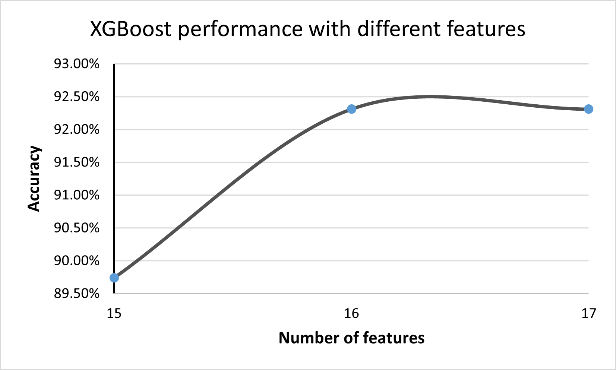
Fig. (4). XGBoost performance with different features

Table 3. Selected features from each feature group
Group | Features | Description
volume | rAmy  lAmy  lSupFroGy  rPosTeLo  lCbe | Right Amygdala  Left Amygdala  Left Superior Frontal Gyrus  Right Posterior Temporal Lobe  Left Cerebellum
Gyrification Index | lparahippocampal  lparacentral  rinferiortemporal  rparsopercularis  rlateralorbitofrontal | Left Para hippocampal  Left paracentral  Right Inferior Temporal  Right Pars opercularis  Right Lateral Orbitofrontal
Sulcal Depth | lsuperiortemporal  lparacentral  rtemporalpole | Left Superior Temporal  Left paracentral  Right Temporal Pole
Cortical Thickness | lentorhinal  lfusiform  rinsula | Left Entorhinal  Left Fusiform  Right Insula

Table 4. Accuracy of the three classifiers (16 selected features)
Classifiers | Accuracy
XGBoost | 92.31%
SVM | 89.18%,
KNN | 89.18%,

Table 5. Classification performance of applied classifiers.
Classifiers | stages | Precision | Recall | F1 score | AUCROC
XGBoost | AD | 0.94 | 0.94 | 0.94 | 0.957
 | MCI | 0.92 | 1 | 0.96 | 0.997
 | NC | 0.9 | 0.82 | 0.86 | 0.909
average |  | 0.92 | 0.92 | 0.92 | 0.9543
SVM | AD | 0.93 | 0.88 | 0.9 | 0.899
 | MCI | 0.92 | 1 | 0.96 | 0.978
 | NC | 0.82 | 0.82 | 0,82 | 0.818
average |  | 0.89 | 0.9 | 0.893 | 0.898
KNN | AD | 0.88 | 0.94 | 0.91 | 0.927
 | MCI | 0.86 | 1 | 0.92 | 0.966
 | NC | 1 | 0.73 | 0.84 | 0.825
average |  | 0.913 | 0.89 | 0.89 | 0.906

Table 6. The accuracy of each original feature group
Classifiers | Volume (71) | GI (68) | SD (68) | CT (68) | Combined (275)
XGBoost | 82.05% | 66.67% | 58.97% | 66.67% |  | 71.79%
SVM | 69.23% | 64.1% | 46.15% | 66.67% |  | 82.05%
KNN | 79.49% | 66.67% | 51.28% | 69.23% |  | 79.49%

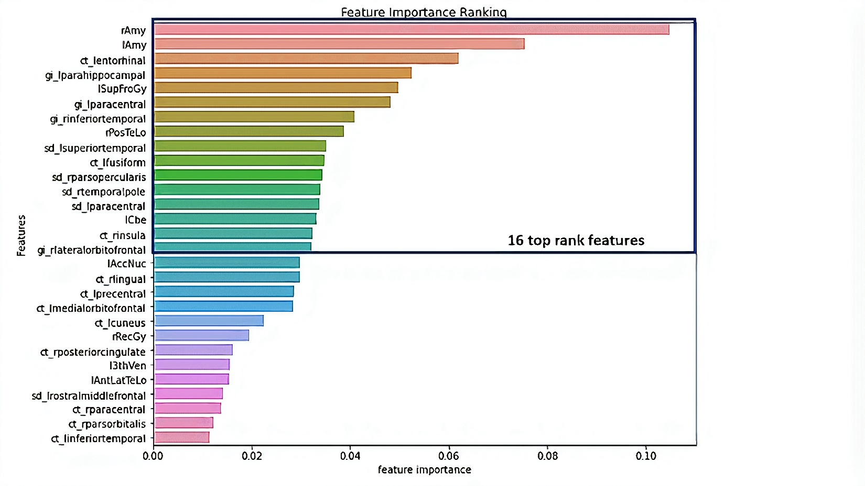
Fig. (5). features importance ranking
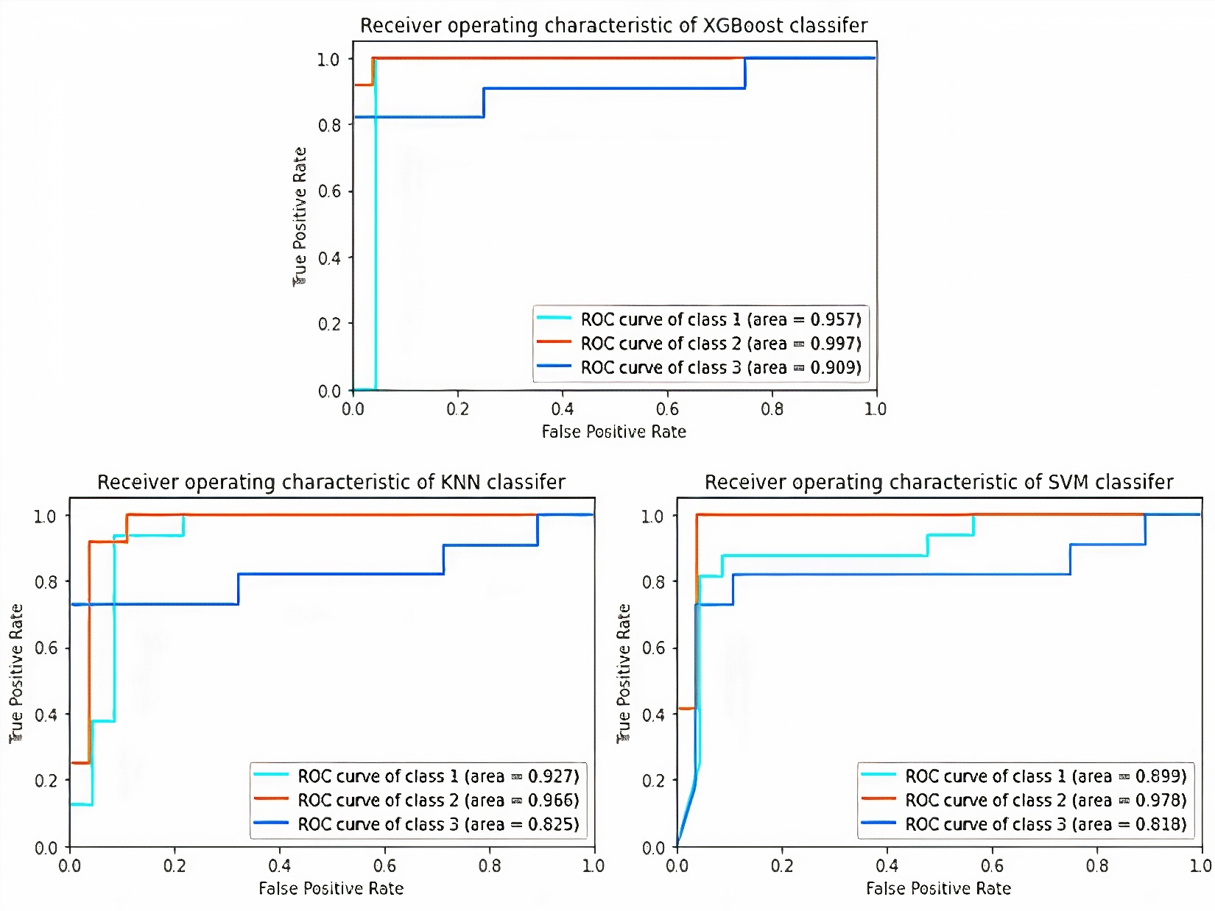
Fig. (6). ROC-AUC for the applied classifiers, class1: AD, class2: MCI, class3: NC

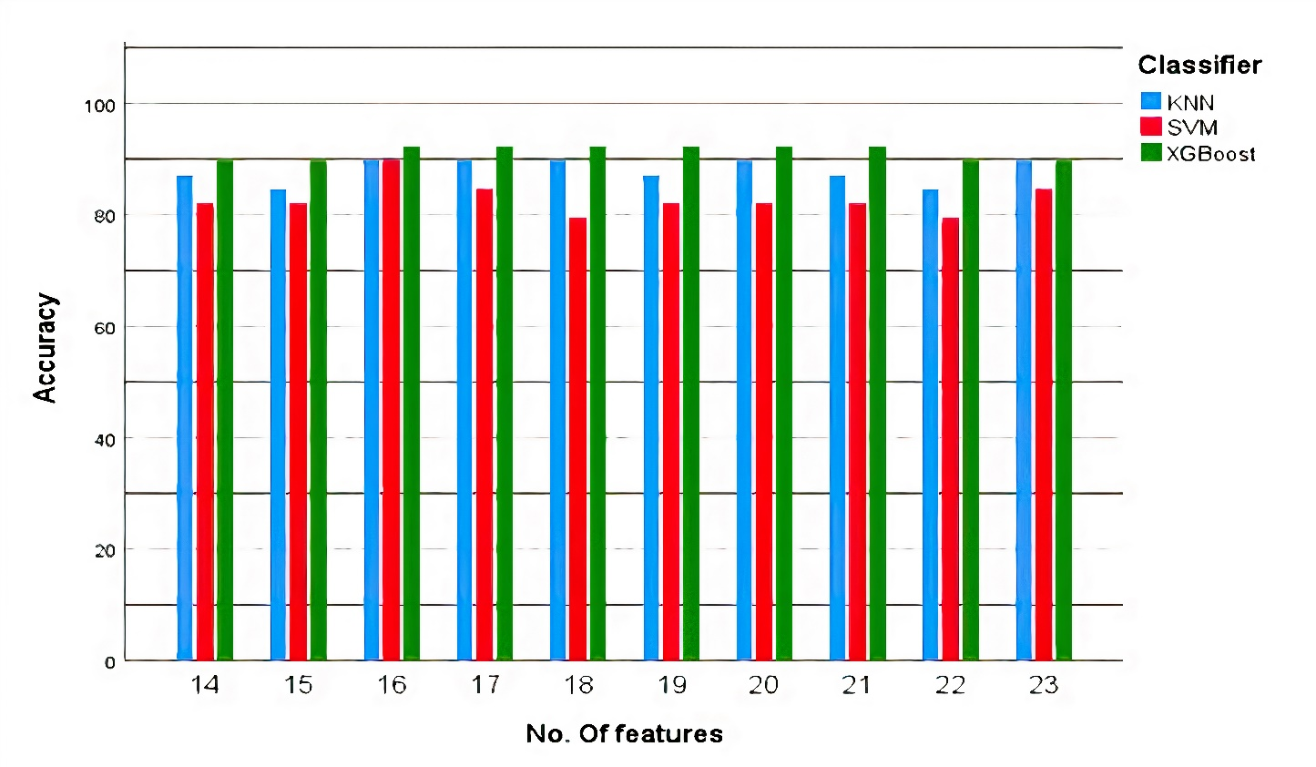
Fig. (7). Model performance with different number of features

4. DISCUSSION
Recent research has reported using multivariable data analysis to classify dementia stages such as MCI and AD, as well as employing machine learning to predict dementia stages. Multivariate analysis studies have found that MCI is characterized by major temporal lobe atrophy, particularly in the superior and inferior temporal gyrus and hippocampus. The same study that classified early MCI in elderly healthy ageing people using only two structural regions in both hemispheres, the amygdala and hippocampus, found the best accuracy of up to 0.9 [43]. Temporal lobes are mostly associated with the encoding of memory and the processing of auditory information. The temporal lobe is also thought to play a critical role in the processing of certain aspects of vision and language [44]. Posterior medial temporal deterioration is related to disturbances in episodic memory in patients with AD [45].
Moreover, there is a study reported that even in the early stages of dementia, the level of amygdala atrophy was associated with the severity of cognitive impairment (as determined by the MMSE and CDR-SB) [16]. In addition, amygdala atrophy is associated with abnormal motor behavior with a potential association with agitation and anxiety [46] which appear in Alzheimer’s. As, it Plays a vital role in the memorizing and processing of emotional responses [47]. The mean volume of the amygdala is 3.17 ${cm}^{3}$ lower than AD which have 2.729 ${cm}^{3}$ average volume [48].
Another study reported that the insular cortex, entorhinal, and fusiform were included with the most significant ROIs to predict a specific score for AD neuropathologic changes [49]. According to post-mortem AD neuropathological examination, entorhinal cortical thickness assessment was significantly related to neurofibrillary tangles in a recent pre-mortem MRI analysis [24]. Insular functions vary from basic functions, such as interoception and gustation, to additional integrative functions, such as decision making, self-awareness, and self-consciousness [50]. Alzheimer's disease (AD) often involves visceral dysfunction and behavioral dyscontrol, which are not found in other disorders that affect cognition. This may be associated with autonomic instability and loss of self-awareness, and pathological changes within the insula cortex may play an important role [51].
On the other hand, the hippocampus and entorhinal cortex are critical for memory, and spatial navigation [52]. The entorhinal cortex sends information to the hippocampus from different areas of the cerebral cortex, collectively known as the association cortex, while also returning processed information by hippocampus back out to the association cortex [53]. These are the first brain regions to be affected in Alzheimer's disease. The average hippocampus volume for 66.27 ± 6.1 years is 5.202 (±0.76) ${cm}^{3}$ and is reduced by 25% in Alzheimer’s [54]. The entorhinal cortex has an average volume of 1.93 ${cm}^{3}$ for NC and 1.417${cm}^{3}$ for AD [55].
Sulci have only been used in a few studies to distinguish between MCI and NC subjects. Among them, Park and his colleagues employed cortical thickness and sulcal depth to classify AD and MCI [56,57]. Sulcal abnormalities have been associated with normal ageing and cognitive impairment in research [58,59]. There is a consensus between most of the features reported in previous studies that are correlated with either MCI or AD, and the features that we employed in our model.
Our approach has the advantage of using a combination of features (volume, CT, GI, and SD) rather than depending on one group of features. As, they complemented each other and covered all the anatomical changes in AD. Besides, it classifies multiple stages of AD in one step and produces excellent results.
There is currently no predictive imaging biomarker for Alzheimer's disease that has confirmed/substantial neuropathologic correlations, especially in the early stage. However, employing the improvement in imaging and machine learning in the early detection of anatomical abnormalities in the prodromal stage, before they become clinically manifest, will be beneficial for preventing disease progression and designing effective treatments. By implementing XGBoost for the selected 16 features of the four groups of MRI images, the classification of NC, MCI, and AD can be performed with an accuracy of 92.31%.

5. CONCLUSION
In the proposed method, we achieved good performance for early-stage AD (MCI) detection, which is the most targeted stage to be identified. Moreover, we investigated the most reliable features for the diagnosis of AD.
This approach relies on using an embedded method such as XGBoost to extract the most important features that represent AD from a large pool of features. In addition, three classifiers (XGBoost, SVM, and KNN) were used to determine the classifier with the highest accuracy. According to all the tested models, XGBoost was the most precise classifier because it had the highest precision, sensitivity, F-score, ROC-AUC, and overall accuracy of 92.31%. Moreover, the following features: rAmy, lAmy, lSupFroGy, rPosTeLo, lCbe, from gyrification index features group: lparahippocampal, lparacentral, rinferiortemporal, rparsopercularis, rlateralorbitofrontal, from sulcal depth features group: lsuperiortemporal, lparacentral, rtemporalpole, from cortical thickness features group: lentorhinal, lfusiform, rinsula are the most important features to detect MCI and AD together with NC. Furthermore, combining the volume features with cortical thickness, sulcal depth, and gyrification index of the brain regions yields more accurate results than using either of them independently.
CONSENT FOR PUBLICATION
Not applicable.
AVAILABILITY OF DATA AND MATERIALS
The data supporting the findings of this study are available within the article.
FUNDING
None
CONFLICT OF INTEREST
The authors declare no conflict of interest.

ACKNOWLEDGMENTS
Data used in this study was acquired from the Alzheimer's Disease Neuroimaging Initiative (ADNI) database (adni.loni.usc.edu). As such, the investigators within the ADNI contributed to the design and implementation of ADNI and/or provided data but did not participate in the analysis or writing of this paper. Data collection and sharing for this project were funded by the Alzheimer's Disease Neuroimaging Initiative (ADNI) (National Institutes of Health Grant U01 AG024904) and DOD ADNI (Department of Defense award number W81XWH-12-2-0012). ADNI is funded by the National Institute on Aging, the National Institute of Biomedical Imaging and Bioengineering, and through generous contributions from the following: AbbVie, Alzheimer's Association; Alzheimer's Drug Discovery Foundation; Araclon Biotech; BioClinica, Inc.; Biogen; Bristol-Myers Squibb Company; CereSpir, Inc.; Cogstate; Eisai Inc.; Elan Pharmaceuticals, Inc.; Eli Lilly and Company; EuroImmun; F. Hoffmann-La Roche Ltd and its affiliated companies Genentech, Inc.; Fujirebio; GE Healthcare; IXICO Ltd.;Janssen Alzheimer Immunotherapy Research & Development, LLC.; Johnson & Johnson Pharmaceutical Research & Development LLC.; Lumosity; Lundbeck; Merck & Co., Inc.;Meso Scale Diagnostics, LLC.; NeuroRx Research; Neurotrack Technologies; Novartis Pharmaceuticals Corporation; Pfizer Inc.; Piramal Imaging; Servier; Takeda Pharmaceutical Company; and Transition Therapeutics. The Canadian Institutes of Health Research is providing funds to support ADNI clinical sites in Canada. Private sector contributions are facilitated by the Foundation for the National Institutes of Health (www.fnih.org). The grantee organization is the Northern California Institute for Research and Education, and the study is coordinated by the Alzheimer's Therapeutic Research Institute at the University of Southern California. ADNI data are disseminated by the Laboratory for Neuro Imaging at the University of Southern California.

Appendix
Names and indices of cortical regions in DKT40.
Regions (left hemisphere) | Regions (right hemisphere)
1 L_bankssts  3 L_Caudalanteriorcingulate  5 L_Caudalmiddlefrontal  7 L_cuneus  9 L_entorhinal  11 L_fusiform,  13 L_inferiorparietal  15 L_inferiortemporal  17 L_isthmuscingulate  19 L_lateraloccipital  21 L_lateralorbitofrontal  23 L_lingual  25 L_medialorbitofrontal  27 L_middletemporal  29 L_parahippocampal  31 L_paracentral  33 L_parsopercularis  35 L_parsorbitalis  37 L_parstriangularis  39 L_pericalcarine  41 L_postcentral  43 L_posteriorcingulate  45 L_precentral  47 L_precuneus  49 L_rostralanteriorcingulate  51 L_rostralmiddlefrontal  53 L_superiorfrontal  55 L_superiorparietal  57 L_superiortemporal  59 L_supramarginal  61 L_frontalpole  63 L_temporalpole,  65 L_transversetemporal  67 L_insula | 2 R_bankssts_right  4 R_Caudalanteriorcingulate  6 R_Caudalmiddlefrontal  8 R_cuneus  10 R_entorhinal  12 R_fusiform  14 R_inferiorparietal  16 R_inferiortemporal  18 R_isthmuscingulate  20 R_lateraloccipital  22 R_lateralorbitofrontal  24 R_lingual  26 R_medialorbitofrontal  28 R_middletemporal,  30 R_parahippocampal  32 R_paracentral  34 R_parsopercularis  36 R_parsorbitalis  38 R_parstriangularis  40 R_pericalcarine  42 R_postcentral  44 R_posteriorcingulate  46 R_precentral  48 R_precuneus  50 R_rostralanteriorcingulate  52 R_rostralmiddlefrontal  54 R_superiorfrontal  56 R_superiorparietal  58 R_superiortemporal  60 R_supramarginal  62 R_frontalpole  64 R_temporalpole  66 R_transversetemporal  68 R_insula

Name and index of the Hammer parcellated volume regions.
Regions (left hemisphere) | Regions (Right hemisphere)
1 L_Hip  3 L_Amy  5 L_AntMedTeLo  7 L_AntLatTeLo  9 L_Amb+ParHipGy  11 L_SupTemGy  13 L_InfMidTemGy  15 L_FusGy  17 L_Cbe  19 L_Bst  21 L_Ins  23 L_LatOcLo  25 L_AntCinGy  27 L_PosCinGy  29 L_MidFroGy  31 L_PosTeLo  33 L_InfLatPaLo  35 L_CauNuc  37 L_AccNuc  39 L_Put  41 L_Tha  43 L_Pal  45 L_CC  47 L_LatTemVen  49 L_3thVen  51 L_PrcGy  53 L_RecGy  55 L_OrbFroGy  57 L_InfFroGy  59 L_SupFroGy  61 L_PoCGy  63 L_SupParGy  65 L_LinGy  67 L_Cun  69 CSF  71 WM | 2 R_Hip  4 R_Amy  6 R_AntMedTeLo  8 R_AntLatTeLo  10 R_rAmb+ParHipGy  12 R_SupTemGy  14 R_InfMidTemGy  16 R_FusGy  18 R_Cbe  20 R_Bst  22 R_Ins  24 R_LatOcLo  26 R_AntCinGy  28 R_PosCinGy  30 R_MidFroGy  32 R_PosTeLo  34 R_InfLatPaLo  36 R_CauNuc  38 R_AccNuc  40 R_Put  42 R_Tha  44 R_Pal  46 R_CC  48 R_LatTemVen  50 R_3thVen  52 R_PrcGy  54 R_RecGy  56 R_OrbFroGy  58 R_InfFroGy  60 R_SupFroGy  62 R_PoCGy  64 R_SupParGy  66R_LinGy  68 R_Cun  70 GM

References
[1] Saravanakumar, S.; Thangaraj, P. A Voxel Based Morphometry Approach for Identifying Alzheimer from MRI Images. Cluster Computing 2018, 22 (S6), 14081-14089.
[2] Wang, W.; Yu, J.; Liu, Y.; Yin, R.; Wang, H.; Wang, J.; Tan, L.; Radua, J.; Tan, L. Voxel-Based Meta-Analysis of Grey Matter Changes in Alzheimer’s Disease. Translational Neurodegeneration 2015, 4 (1).
[3] Matsuda, H.; Voxel-based Morphometry of Brain MRI in Normal Aging and Alzheimer’s Disease. Aging and Disease 2013, 4(1), 29–37.
[4] Lopez-Garcia, P.; Aizenstein, H.; Snitz, B.; Walter, R.; Carter, C. Automated ROI-based brain parcellation analysis of frontal and temporal brain volumes in schizophrenia. Psychiatry Research: Neuroimaging 2006, 147 (2-3), 153-161.
[5] Seyedi, S.; Jafari, R.; Talaei, A.; Naseri, S.; Momennezhad, M.; Moghaddam, M.; Akbari-Lalimi, H. Comparing VBM and ROI analyses for detection of gray matter abnormalities in patients with bipolar disorder using MRI. Middle East Current Psychiatry 2020, 27 (1).
[6] Tavares, V.; Prata, D.; Ferreira, H. Comparing SPM12 and CAT12 segmentation pipelines: a brain tissue volume-based age and Alzheimer’s disease study. Journal of Neuroscience Methods 2020, 334, 108565.
[7] Seiger, R.; Ganger, S.; Kranz, G.; Hahn, A.; Lanzenberger, R. Cortical Thickness Estimations of FreeSurfer and the CAT12 Toolbox in Patients with Alzheimer’s Disease and Healthy Controls. Journal of Neuroimaging 2018, 28 (5), 515-523.
[8] Sørensen, L.; Igel, C.; Pai, A.; Balas, I.; Anker, C.; Lillholm, M.; Nielsen, M. Differential diagnosis of mild cognitive impairment and Alzheimer’s disease using structural MRI cortical thickness, hippocampal shape, hippocampal texture, and volumetry. NeuroImage: Clinical 2017, 13, 470-482.
[9] Bartos, A.; Gregus, D.; Ibrahim, I.; Tintěra, J. Brain volumes and their ratios in Alzheimer’s disease on magnetic resonance imaging segmented using Freesurfer 6.0. Psychiatry Research: Neuroimaging 2019, 287, 70-74.
[10] Achterberg, H.; van der Lijn, F.; den Heijer, T.; Vernooij, M.; Ikram, M.; Niessen, W.; de Bruijne, M. Hippocampal shape is predictive for the development of dementia in a normal, elderly population. Human Brain Mapping 2013, 35 (5), 2359-2371.
[11] Sørensen, L.; Igel, C.; Liv Hansen, N.; Osler, M.; Lauritzen, M.; Rostrup, E.; Nielsen, M. Early detection of Alzheimer's using MRI hippocampal texture. Human Brain Mapping 2015, 37 (3), 1148-1161.
[12] Liu, T.; Lipnicki, D.; Zhu, W.; Tao, D.; Zhang, C.; Cui, Y.; Jin, J.; Sachdev, P.; Wen, W. Cortical Gyrification and Sulcal Spans in Early-Stage Alzheimer's Disease. PLoS ONE 2012, 7 (2), e31083.
[13] Racine, A.; Brickhouse, M.; Wolk, D.; Dickerson, B. The personalized Alzheimer’s disease cortical thickness index predicts likely pathology and clinical progression in mild cognitive impairment. Alzheimer's & Dementia: Diagnosis, Assessment & Disease Monitoring 2018, 10 (1), 301-310.
[14] Cai, K.; Xu, H.; Guan, H.; Zhu, W.; Jiang, J.; Cui, Y.; Zhang, J.; Liu, T.; Wen, W. Identification of Early-Stage Alzheimer's Disease Using Sulcal Morphology and Other Common Neuroimaging Indices. PLOS ONE 2017, 12 (1), e0170875.
[15] Boutet, C.; Chupin, M.; Lehéricy, S.; Marrakchi-Kacem, L.; Epelbaum, S.; Poupon, C.; Wiggins, C.; Vignaud, A.; Hasboun, D.; Defontaines, B.; Hanon, O.; Dubois, B.; Sarazin, M.; Hertz-Pannier, L.; Colliot, O. Detection of volume loss in hippocampal layers in Alzheimer's disease using 7 T MRI: a feasibility study. NeuroImage: Clinical 2014, 5, 341-348.
[16] Poulin, S.; Dautoff, R.; Morris, J.; Barrett, L.; Dickerson, B. Amygdala atrophy is prominent in early Alzheimer's disease and relates to symptom severity. Psychiatry Research: Neuroimaging 2011, 194 (1), 7-13.
[17] Prestia, A.; Boccardi, M.; Galluzzi, S.; Cavedo, E.; Adorni, A.; Soricelli, A.; Bonetti, M.; Geroldi, C.; Giannakopoulos, P.; Thompson, P.; Frisoni, G. Hippocampal and amygdalar volume changes in elderly patients with Alzheimer’s disease and schizophrenia. Psychiatry Research: Neuroimaging 2011, 192 (2), 77-83.
[18] Weiner, M.; Veitch, D.; Aisen, P.; Beckett, L.; Cairns, N.; Green, R.; Harvey, D.; Jack, C.; Jagust, W.; Liu, E.; Morris, J.; Petersen, R.; Saykin, A.; Schmidt, M.; Shaw, L.; Siuciak, J.; Soares, H.; Toga, A.; Trojanowski, J. The Alzheimer's Disease Neuroimaging Initiative: a review of papers published since its inception. Alzheimer's & Dementia 2011, 8 (1S).
[19] Devanand, D.; Bansal, R.; Liu, J.; Hao, X.; Pradhaban, G.; Peterson, B. MRI hippocampal and entorhinal cortex mapping in predicting conversion to Alzheimer’s disease. NeuroImage 2012, 60 (3), 1622-1629.
[20] Rohini, P.; Sundar, S.; Ramakrishnan, S. Characterization of Alzheimer conditions in MR images using volumetric and sagittal brainstem texture features. Computer Methods and Programs in Biomedicine 2019, 173, 147-155.
[21] Apostolova, L.; Green, A.; Babakchanian, S.; Hwang, K.; Chou, Y.; Toga, A.; Thompson, P. Hippocampal Atrophy and Ventricular Enlargement in Normal Aging, Mild Cognitive Impairment (MCI), and Alzheimer Disease. Alzheimer Disease & Associated Disorders 2012, 26 (1), 17-27.
[22] Núñez, C.; Callén, A.; Lombardini, F.; Compta, Y.; Stephan‐Otto, C. Different Cortical Gyrification Patterns in Alzheimer's Disease and Impact on Memory Performance. Annals of Neurology 2020, 88 (1), 67-80.
[23] Falahati, F.; Westman, E.; Simmons, A. Multivariate data analysis and machine learning in Alzheimer's disease with a focus on structural magnetic resonance imaging. Journal of Alzheimer's Disease 2014, 41 (3), 685-708.
[24] Rallabandi, V.; Tulpule, K.; Gattu, M. Automatic classification of cognitively normal, mild cognitive impairment and Alzheimer’s disease using structural MRI analysis. Informatics in Medicine Unlocked 2020, 18, 100305.
[25] Liu, M.; Zhang, D.; Shen, D. Ensemble sparse classification of Alzheimer’s disease. NeuroImage 2012, 60 (2), 1106-1116.
[26] Kruthika, K.; Rajeswari; Maheshappa, H. Multistage classifier-based approach for Alzheimer’s disease prediction and retrieval. Informatics in Medicine Unlocked 2019, 14, 34-42.
[27] Tuan, T.; Pham, T.; Kim, J.; Tavares, J. Alzheimer’s diagnosis using deep learning in segmenting and classifying 3D brain MR images. International Journal of Neuroscience 2020, 1-10.
[28] Richhariya, B.; Tanveer, M.; Rashid, A. Diagnosis of Alzheimer’s disease using universum support vector machine based recursive feature elimination (USVM-RFE). Biomedical Signal Processing and Control 2020, 59, 101903.
[29] Beheshti, I.; Demirel, H.; Matsuda, H. Classification of Alzheimer's disease and prediction of mild cognitive impairment-to-Alzheimer's conversion from structural magnetic resource imaging using feature ranking and a genetic algorithm. Computers in Biology and Medicine 2017, 83, 109-119.
[30] Yang, S.; Lee, J.; Chang, T.; Huang, C.; Wang, J.; Hsu, W.; Chan, H.; Wai, Y.; Li, K. Discrimination between Alzheimer’s disease and mild cognitive impairment using SOM and PSO-SVM. Computational and Mathematical Methods in Medicine 2013, 1-10.
[31] Long, X.; Chen, L.; Jiang, C.; Zhang, L. Prediction and classification of Alzheimer disease based on quantification of MRI deformation. PLOS ONE 2017, 12 (3), e0173372.
[32] Lee, J.; Kim, C.; Shin, J.; Cho, H.; Shin, D.; Kim, N.; Kim, H.; Kim, Y.; Lockhart, S.; Na, D.; Seo, S.; Seong, J. Machine Learning-based Individual Assessment of Cortical Atrophy Pattern in Alzheimer’s Disease Spectrum: Development of the Classifier and Longitudinal Evaluation. Scientific Reports 2018, 8 (1).
[33] Manjón, J.; Coupé, P.; Martí-Bonmatí, L.; Collins, D.; Robles, M. Adaptive non-local means denoising of MR images with spatially varying noise levels. Journal of Magnetic Resonance Imaging 2009, 31 (1), 192-203.
[34] Rajapakse, J.; Giedd, J.; Rapoport, J. Statistical approach to segmentation of single-channel cerebral MR images. IEEE Transactions on Medical Imaging 1997, 16 (2), 176-186.
[35] Ashburner, J. A fast diffeomorphic image registration algorithm. NeuroImage 2007, 38 (1), 95-113.
[36] Hammers, A.; Allom, R.; Koepp, M.; Free, S.; Myers, R.; Lemieux, L.; Mitchell, T.; Brooks, D.; Duncan, J. Three-dimensional maximum probability atlas of the human brain, with particular reference to the temporal lobe. Human Brain Mapping 2003, 19 (4), 224-247.
[37] Dahnke, R.; Yotter, R.; Gaser, C. Cortical thickness and central surface estimation. NeuroImage 2013, 65, 336-348.
[38] Analytics Vidhya. Introduction to Feature Selection methods with an example (or how to select the right variables?). https://www.analyticsvidhya.com/blog/2016/12/introduction-to-feature-selection-methods-with-an-example-or-how-to-select-the-right-variables. (Accessed October 6, 2021).
[39] Chandrashekar, G.; Sahin, F. A survey on feature selection methods. Computers & Electrical Engineering 2014, 40 (1), 16-28.
[40] Chen, T.; Guestrin, C. In 22nd ACM SIGKDD International Conference on Knowledge Discovery and Data Mining; Association for Computing Machinery 2016; pp 785–794.
[41] Keerthi, S.; Lin, C. Asymptotic behaviors of support vector machines with Gaussian kernel. Neural Computation 2003, 15 (7), 1667-1689.
[42] Ali, N.; Neagu, D.; Trundle, P. Evaluation of k-nearest neighbour classifier performance for heterogeneous data sets. SN Applied Sciences 2019, 1 (12).
[43] Fan, Y.; Batmanghelich, N.; Clark, C.; Davatzikos, C. Spatial patterns of brain atrophy in MCI patients, identified via high-dimensional pattern classification, predict subsequent cognitive decline. NeuroImage 2008, 39 (4), 1731-1743.
[44] The State of Queensland (Queensland Health). Brain Map: Temporal Lobes. https://www.health.qld.gov.au/abios/asp/btemporal_lobes. Accessed (May 16, 2022)
[45] Schwab, S.; Afyouni, S.; Chen, Y.; Han, Z.; Guo, Q.; Dierks, T.; Wahlund, L.; Grieder, M. Functional Connectivity Alterations Of The Temporal Lobe And Hippocampus In Semantic Dementia And Alzheimer’S Disease. Journal of Alzheimer's Disease 2020, 76 (4), 1461-1475.
[46] Poulin, S.P.; Dautoff R.; Morris J.C.; Barrett L.F.; Dickerson B.C.; Alzheimer's Disease Neuroimaging Initiative. Amygdala atrophy is prominent in early Alzheimer's disease and relates to symptom severity. Psychiatry Res 2011;194(1):7-13.
[47] SimplyPsychology. Amygdala Function and Location. https://www.simplypsychology.org/amygdala.html. Accessed (May 16, 2022)
[48] Barnes, J.; Whitwell, J.; Frost, C.; Josephs, K.; Rossor, M.; Fox, N. Measurements Of The Amygdala And Hippocampus In Pathologically Confirmed Alzheimer Disease And Frontotemporal Lobar Degeneration. Archives of Neurology 2006, 63(10), 1434.
[49] Kautzky, A.; Seiger, R.; Hahn, A.; Fischer, P.; Krampla, W.; Kasper, S.; Kovacs, G.; Lanzenberger, R. Prediction of Autopsy Verified Neuropathological Change of Alzheimer's Disease Using Machine Learning and MRI. Frontiers in Aging Neuroscience 2018, 10.
[50] Philippi, N.; Noblet, V.; Hamdaoui, M.; Soulier, D.; Botzung, A.; Ehrhard, E.; Cretin, B.; Blanc, F. The Insula, A Grey Matter Of Tastes: A Volumetric MRI Study In Dementia With Lewy Bodies. Alzheimer's Research &amp; Therapy 2020, 12 (1).
[51] Bonthius, D.; Solodkin, A.; Van Hoesen, G. Pathology Of The Insular Cortex In Alzheimer Disease Depends On Cortical Architecture. Journal of Neuropathology and Experimental Neurology 2005, 64 (10), 910-922.
[52] Anand, K.; Dhikav, V. Hippocampus In Health And Disease: An Overview. Annals of Indian Academy of Neurology 2012, 15 (4), 239.
[53] McKhann, G.M.; Knopman, D.S.; Chertkow, H.; Hyman, B.T.; Jack Jr, C.R.; Kawas, C.H.; Klunk, W.E.; Koroshetz, W.J.; Manly, J.J.; Mayeux, R.; Mohs, R.C.; Morris, J.C.; Rossor, M.N.; Scheltens, P.; Carrillo, M.C.; Thies,B.; Weintraub, S.; Phelps, C.H. The diagnosis of dementia due to Alzheimer’s disease: recommendations from the National Institute on Aging-Alzheimer’s Association workgroups on diagnostic guidelines for Alzheimer’s disease. Alzheimer's & Dementia 2011, 7 (3), 263-269.
[54] Vijayakumar, A.; Vijayakumar, A. Comparison Of Hippocampal Volume In Dementia Subtypes. ISRN Radiology 2013, 2013, 1-5.
[55] Leandrou, S.; Lamnisos, D.; Mamais, I.; Kyriacou, P.; Pattichis, C. Assessment Of Alzheimer’S Disease Based On Texture Analysis Of The Entorhinal Cortex. Frontiers in Aging Neuroscience 2020, 12.
[56] Park, H.; Yang, J.; Seo, J.; Lee, J. Dimensionality reduced cortical features and their use in the classification of Alzheimer's disease and mild cognitive impairment. Neuroscience Letters 2012, 529 (2), 123-127.
[57] Park, H.; Yang, J.; Seo, J.; Lee, J. Dimensionality reduced cortical features and their use in predicting longitudinal changes in Alzheimer's disease. Neuroscience Letters 2013, 550, 17-22.
[58] Kochunov, P.; Mangin, J.; Coyle, T.; Lancaster, J.; Thompson, P.; Rivière, D.; Cointepas, Y.; Régis, J.; Schlosser, A.; Royall, D.; Zilles, K.; Mazziotta, J.; Toga, A.; Fox, P. Age-related morphology trends of cortical sulci. Human Brain Mapping 2005, 26 (3), 210-220.
[59] Liu, T.; Wen, W.; Zhu, W.; Trollor, J.; Reppermund, S.; Crawford, J.; Jin, J.; Luo, S.; Brodaty, H.; Sachdev, P. The effects of age and sex on cortical sulci in the elderly. NeuroImage 2010, 51 (1), 19-27.

